**Name: Suyog Bodke**

**Roll no: 281006**

**Batch: A1**

**Assignment 7**

**Statement**

**Q.** This assignment involves building a **classification model** to predict whether a student will get **admission** based on GRE score and academic profile. The dataset includes features such as GRE Scores, TOEFL Scores, University Rating, SOP & LOR Strength, GPA, Research Experience, and Admission Status (Target: 0 or 1).

**Dataset Link**:  
[Graduate Admissions Dataset – Kaggle](https://www.kaggle.com/mohansacharya/graduate-admissions)

A **counselor** needs assistance in predicting admission chances using GRE score and academic performance. To support this decision-making, a **Decision Tree classifier** will be applied.

**Tasks:**

a) Apply **data preprocessing** (Label Encoding, Transformation, etc.)  
b) Perform **train-test splitting**  
c) Implement **Decision Tree** classifier  
d) **Evaluate** the model performance

**Objective**

1. Build a **Decision Tree** classification model to predict admission chances.
2. Apply necessary **data preprocessing** for accurate modeling.
3. Evaluate model using standard **classification metrics**.

**Resources Used**

* **Software**: Google Colab
* **Libraries**: Pandas, Scikit-learn, Matplotlib, Seaborn

**Introduction to Classification**

Classification is a **supervised machine learning** approach where input data is assigned to a category or class label. In this task, we classify whether a student gets **admitted (Yes/No)** based on their academic indicators.

**Methodology**

1. **Data Collection & Preprocessing**
   * Load dataset from Kaggle
   * Check and handle missing values, duplicates, and outliers
   * Perform **Label Encoding** for categorical variables like Research
   * Normalize/scale features if needed
2. **Data Preparation**
   * Select important features: GRE Score, TOEFL Score, University Rating, GPA, Research
   * Define Admitted as the **target**
   * Use **train_test_split** (80:20 or 70:30)
3. **Model Building**
   * Apply DecisionTreeClassifier from sklearn.tree
   * Fit the model on training data
   * Predict on test data
4. **Model Evaluation**
   * Evaluate using **Accuracy**, **Precision**, **Recall**, **F1-Score**
   * Generate and interpret a **Confusion Matrix**

**Advantages of Decision Tree Classification**

* Easy to understand and **visualize**
* Handles both **categorical and numerical** data
* Requires **minimal data preprocessing**

**Disadvantages**

* Can **overfit** if not pruned
* May perform poorly with **imbalanced** data

**Conclusion**

In this assignment, a **Decision Tree classifier** was successfully developed to predict student admissions. With proper preprocessing and evaluation, the model can assist counselors in making reliable decisions based on a student's GRE score and academic background. This showcases the power of **classification techniques** in the field of **educational data mining**.

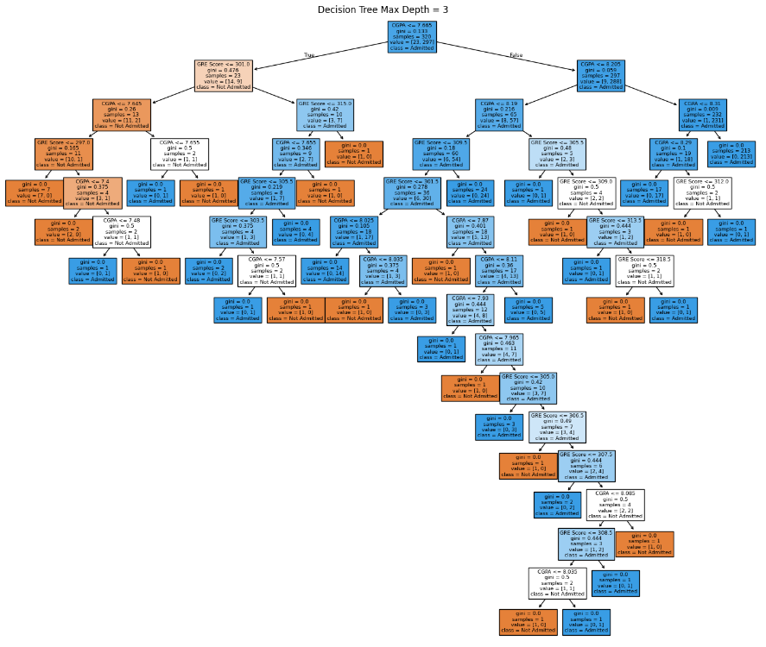**Output**